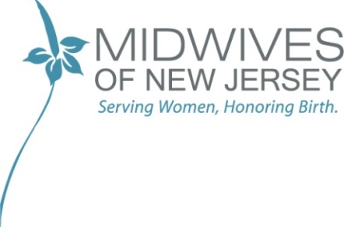

Notice of Privacy Practices

I acknowledge that I was provided a copy of the privacy at The Midwives of New Jersey LLC, and I have had an opportunity to read the policies as listed.

Patient/Employee Print Name Date

Signature

