Extended Breast Questionnaire
Diagnosed with breast cancer
Cancer type: Metastatic Local Lymph node involvement
When diagnosed: Month Year
Where (left breast): UO UI LO LI Nipple
Where (right breast): UO UI LO LI Nipple
Treatment: Surgery Chemo Radiation Other None
Diagnosed with other breast disease:
Disease type: Fibrocystic Cystic Mastitis Abscess Other
(please report other types of disease in the history)
Breast biopsies or surgery:
Where (left breast): UO UI LO LI Nipple
Where (right breast): UO UI LO LI Nipple

Name: D.O.B:
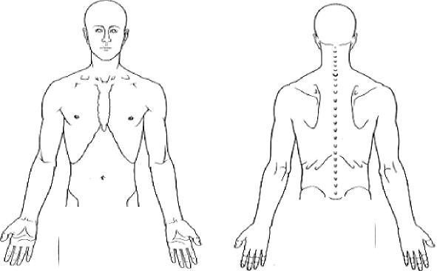
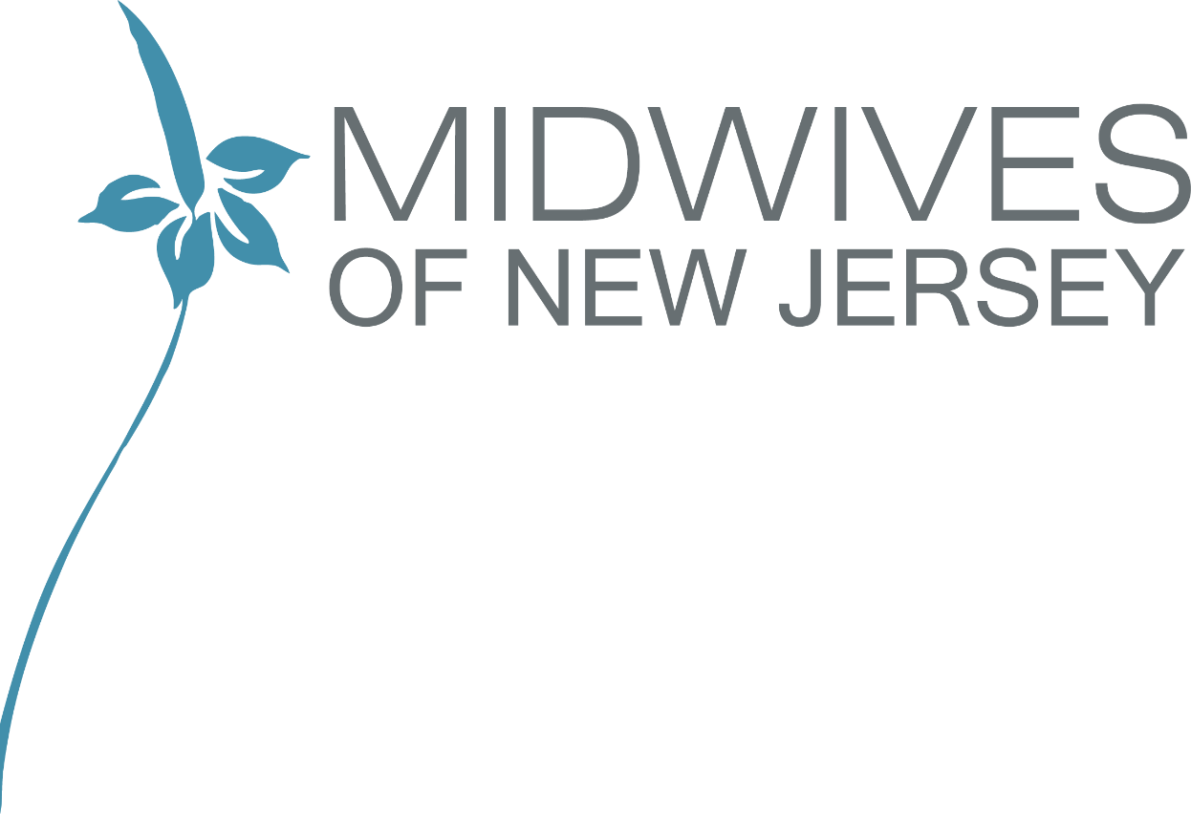
All information given in the questionnaire will remain strictly confidential and will only be
divulged to the reporting thermologist and any other practitioner that you specify.
Upper Body Study Questionnaire
Address:
Phone. Your Doctor:
Please Show areas of :

Main Pain
Secondary Pain 0
Numbness ////////
Pins and needles
Skin lesions / scaring

Do you know what triggered the pain ?
Does anything relieve it ?
Does anything aggravate it ?
Has it changed since it began ?
Have you had any treatment ?
History: Injuries / Fractures / Surgery

PATIENT DISCLOSURE
I understand that the Report generated from my images is intended for use by trained health care providers to assist
in evaluation, diagnosis and treatment. I further understand that the Report is not intended to be used by individuals for self-
evaluation or self-diagnosis.
I understand that the Report will not tell me whether I have any illness, disease, or other condition but will be an
analysis of the Images with respect only to the thermographic findings of the areas discussed in the Report.
By signing below, I certify that I have read and understand the statements above and consent to the examination.
Signature

Previous Illnesses.
Patient Information Sheet.
Name D 0 B
Address
Phone (H) (W)
Occupation
Previous Surgery.
Current Health Problems.

Medication
Other Treatment
Current Doctor.
Do you want a copy of the thermogram report forwarded to your doctor ?
Yes No
This information is confidential.
All information is correct to my Knowledge.
Signed Date

